DIS-Pipe- Mississippian trophy head pipe

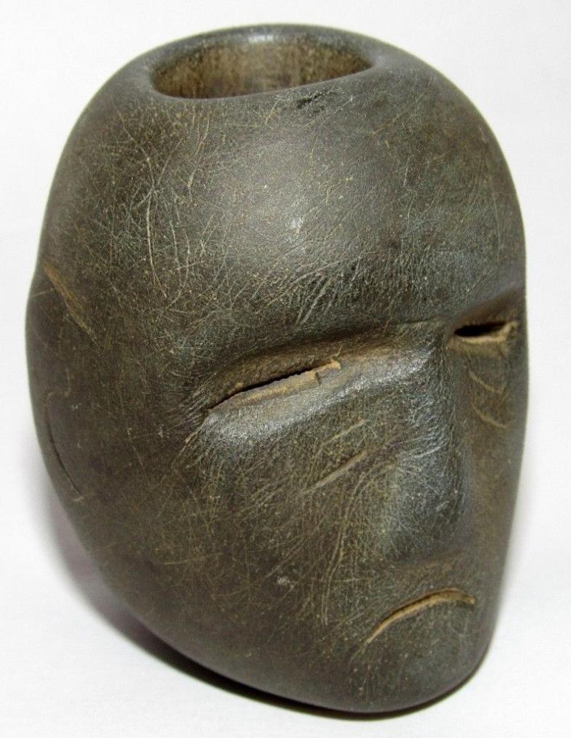 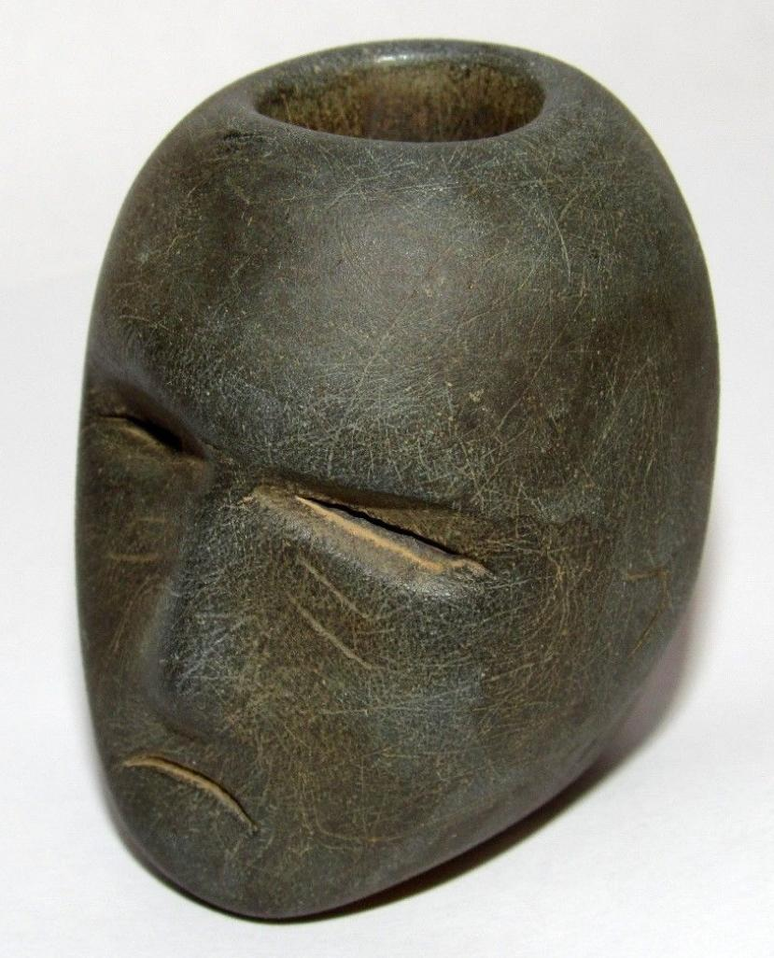 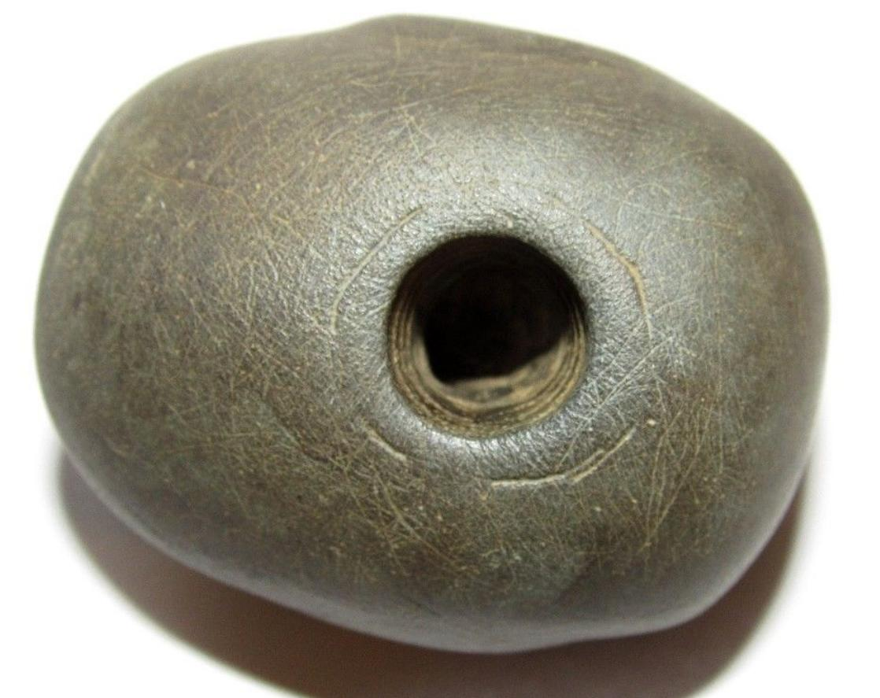 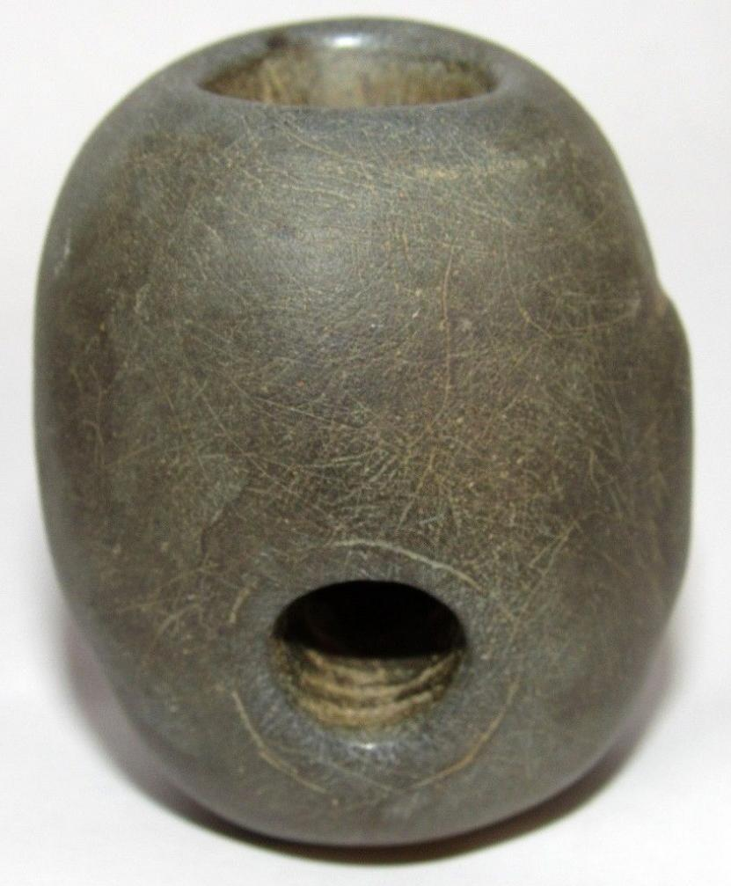 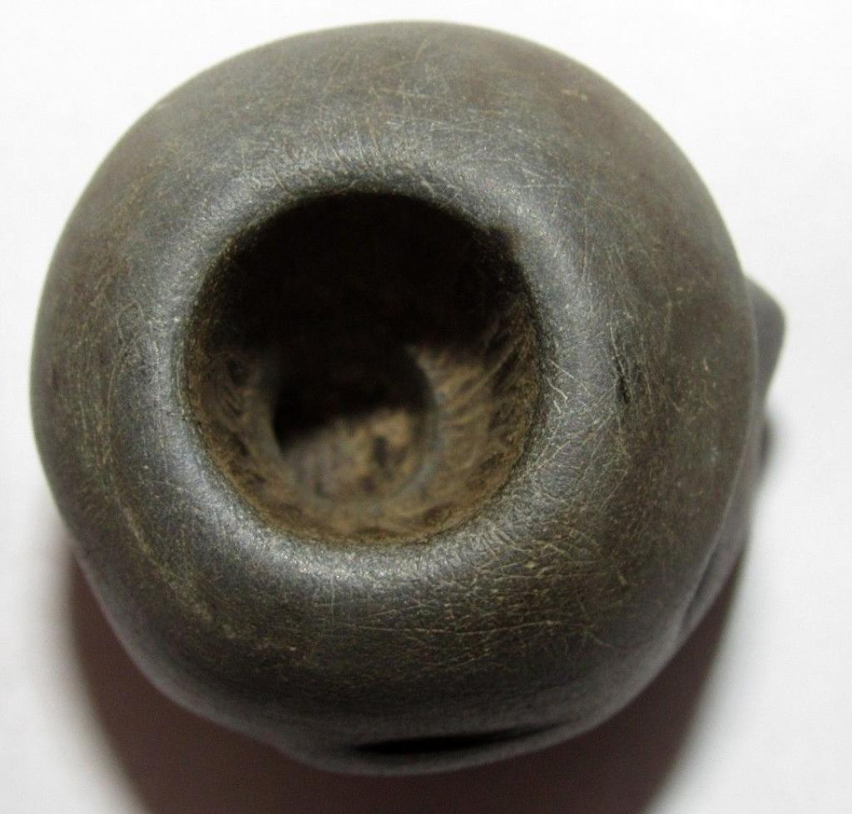

Mississippian effigy trophy head effigy peace pipe from Arkansas, ca. 1200’s. The facial expression is comparable to the trophy human heads on Mississippian pottery of the same era. Trophy head pipes were smoked by warriors after a successful battle. The pipe has an authentic patina and other than some minor surface wear, it is in excellent condition.

It measures 2 inches tall, 1 5/8 inches wide and 1 3/4 inches from back to front.

|  |  |
| --- | --- |
| ORDER DATEApr 10, 2016 | ORDER TOTAL  US $192.50  + US $4.35  shipping  **Order Old Stone Indian Artifact Human Head Effigy Peace Pipe Arkansas Native American** [Leave feedback - ORDER DATE Apr 10, 2016](http://feedback.ebay.com/ws/eBayISAPI.dll?LeaveFeedbackShow&useridto=claws-teeth-bones&transactID=0&item=361523895226&_trksid=p2057872.m2749.l2665)[View order details](http://payments.ebay.com/ws/eBayISAPI.dll?ViewPaymentStatus&transId=0&itemid=361523895226&_trksid=p2057872.m2749.l2673) - ORDER DATE Apr 10, 2016  [More actions - ORDER DATE Apr 10, 2016](http://www.ebay.com/myb/PurchaseHistory) |

1 item sold by [claws-teeth-bones](http://www.ebay.com/usr/claws-teeth-bones?_trksid=p2057872.m2749.l2754)

|  |  |  |
| --- | --- | --- |
| [Old Stone Indian Artifact Human Head Effigy Peace Pipe Arkansas Native American](http://www.ebay.com/itm/361523895226?_trksid=p2057872.m2749.l2649&ssPageName=STRK%3AMEBIDX%3AIT)  ( 361523895226 )  Delivered on Thu, Apr 14  Tracking number: [**Tracking number**9416509699939854443175](javascript:;)  [Add note](javascript:;) | ITEM PRICE:  US $192.50 |  |